## UML Diagrams

### UML Activity Diagrams

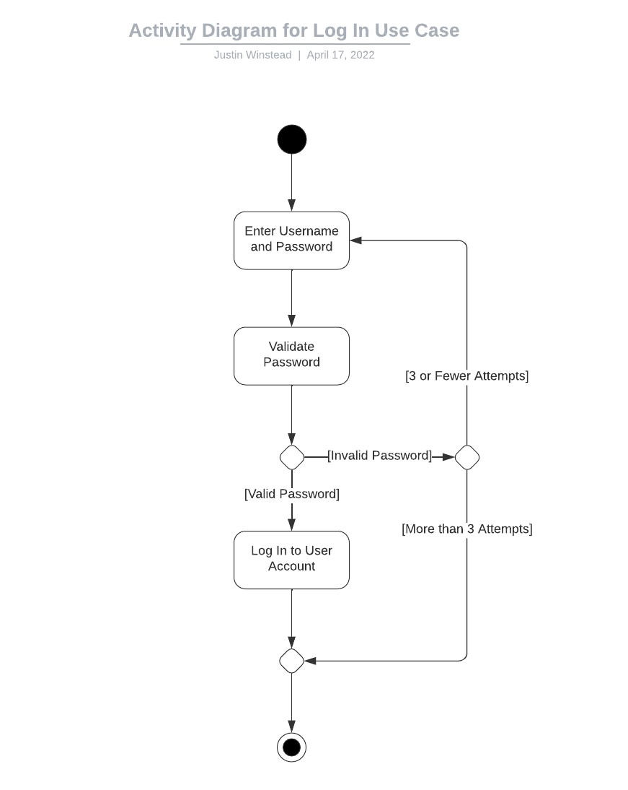

### UML Sequence Diagram

## Technical Requirements

The system must:

* Run in a cloud-based environment like Amazon Web Services or Microsoft Azure
* Support offline data access
* Store any passwords after processing them with a hashing algorithm
* Reject any login attempts for an account after 5 failed attempts
* Communicate with the DMV for course information
* Relay all payment information to a third-party payment processor
* Communicate with the third-party authentication service
* Update on the first Sunday of each month from 1-3AM
* Contact DriverPass owner within 15 minutes of a system failure